Practicing the art of life
During Lent my lovely niece sent me a reflection entitled ‘The Art of Life’ written by the author & broadcaster, Brian Draper. He wrote about an artist friend of his who had described the art he produced as his ‘practice.’ It wasn’t only about the end product but about the way he looked at things, the preparation he did and the different stage this involved. Brian Draper stated, ‘The end and the means are of equal worth.’
This connected with something I had experienced when trying to paint a watercolour of a Yorkshire scene in February. I wasn’t at all happy with the end result, feeling very dejected and rather dramatically felt like giving up altogether! ‘It’s rubbish!’ I said to myself and Stephen. However, I returned to it much later and calmly decided to see it as an experiment and exploration, a way of practice and discovery rather than worrying about the end result. I slowed down, took my time and in the end, to my surprise, led to a result with which I was much happier. The process was what mattered, and as I gradually honed this piece of art, I began to see what worked and what needed to be let go of.
It struck me later that this experience so reflects the journey we are all on with God. Often, we can be striving to get things right, driven sometimes by desire for perfection and a need to be in control, and so become discouraged and disheartened, forgetting that our Creator God sees us as a work in progress. Our lives at times can feel messy, weighed down and disappointing, even to the point of wanting to give up. The poet George Herbert experienced this and wrote about his desire to take off in his poem, ‘The Collar.’ He describes how he had had enough,
I struck the board and cryd, No more
I will abroad.
What? shall I ever sigh and pine?

Thankfully God lets him have his rant, and at the end of the poem we are reminded that God never abandons us:

But as I raved and grew more fierce and wilde
At every word,
Me thoughts I heard one calling, Childe:
And I reply’d, My Lord

We, like Herbert, are reminded that we are his children, and are fully known and accepted by him. As we ask the question, ‘What is my life really looking like right now?’, we are being invited to entrust to God all the many areas which we imagine God doesn’t want to see and that we would like to reject. We are as Brian Draper says ‘a work in progress…as we learn to practice the wonderful art of life.’ Another artist Makoto Fujimura writes:
The good news of the bible is that in Christ, we are journeying towards ultimate wholeness, integration and well being. We are becoming more fully what we were made to be to the benefit of all creation.’
So as we come into silence let us relax in the knowledge that no matter where we find ourself on life’s journey, we are being honed and shaped along the way by our always loving Creator.
Leading into the silence
‘Walk with me and work with me – watch how I do it. Learn the unforced rhythms of grace.’
Matthew 11:29 (The Message)
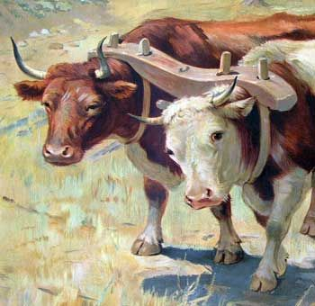
‘Take my yoke upon you and learn of me:
for I am gentle and lowly in heart
and you shall find rest for your souls’ Matthew 11:29

Leading from the silence
‘We are God’s work of art, created in Christ Jesus for the good works which God has already designated to make up our way of life.’ Ephesians 2:10
(New Jerusalem Bible)

