What hope is
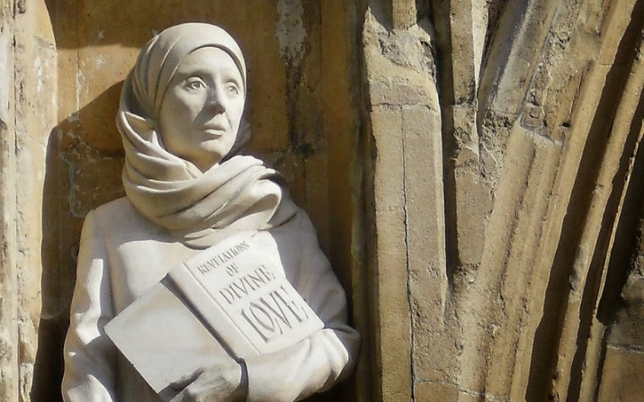 Julian of Norwich
It’s easy to be gloomy – and it’s not helped by all the rain! We have plenty of troubling anxieties - climate change, war in the Holy Land and Ukraine, dissatisfaction in our own country, someone in our family is hurting, and – for many – painful health problems. On a human level it’s hard to be hopeful.
Julian of Norwich has a lot to say about hope, and much of what I’m saying is from a book by Teresa White (‘Hope and the Nearness of God’, pub Bloomsbury, 2022) which looks at the meaning of hope for Christians. Hope, says Teresa White, is not blind or unreal optimism, but something rooted in our relationship with God. Julian – as most of you will know – lived in troubling times too. Black Death bubonic plague had killed half the population of Norwich; the so-called Peasants’ Revolt against a life of hunger and drudgery was violently repressed; she herself was seriously ill when she was 30 years old. Teresa White writes:
‘Julian faces head-on the problem of suffering, and her hope-filled insights have an amazingly contemporary ring. … She tells us that when our whole world breaks up around us, when we experience loneliness and depression, when physical or mental pain take hold of us, it is good to remember that God is with us in it all.’
‘Julian teaches us to be receptive, and – for her – receptivity means creatively waiting on God. There is empowerment in the waiting. It means living in hope, the hope of future glory. Without meaning, suffering can destroy us; but if we find a meaning, it can transform us. Julian has shown that love was that meaning.’
This is encapsulated in Julian’s well-known words about the meaning of life - worth hearing again:
I desired oftentimes to know what was our Lord’s meaning [in times of sorrow and darkness].… I was answered with spiritual understanding, saying thus: “Would you know the Lord’s meaning in this thing? Know it well, love was his meaning. Who showed it to you? Love. What did he show you? Love. Why did he show it to you? Love.” Thus I was taught that Love was our Lord’s meaning.
‘Hope comes to birth in our world each time we hunger and thirst for what is right, each time we resist the temptation towards racism or marginalization, each time we welcome the stranger and stretch out our hand to help someone in need. … If we do any or all of these things, we fan a spark of hope into a living flame of love, and we mirror the God who makes goodness come out of evil.’
To lead into the silence of our creatively waiting on God with a receptive mind
Why are you so cast down, O my soul, and why are you so disquieted with me? Hope in God; for I will again praise him, my help and my God. Psalm 42; 6-7 NRSV
To lead from the silence
For I am convinced that neither death, nor life, nor angels, nor rulers, nor things present, nor things to come, nor powers, nor height, nor depth, nor anything else in all creation, will be able to separate us from the love of God in Christ Jesus our Lord.

