**Solid Ground**

Last week I had the joy of participating in a reflection day led by Margaret Silf on ‘*Finding solid ground in times of turmoil*’. Over the day, I realised that the growing global unrest has made me quite unsettled and this was making it difficult for me to find clarity for this reflection.

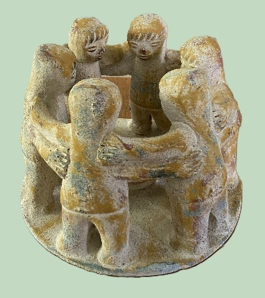

We are living through times of extreme and accelerating change and transition in the world. It is as though several streams are converging from different directions, with each stream becoming more troubled as it flows. Merging, they become an overwhelming violent force that threatens the world as we have known it. The foundations of our settled world order are being shaken from multiple directions and the fault lines and blind spots in our Western society are being laid bare just as much as others.

Such turbulence has the potential to suck us down; we see plenty of anger and hate-filled rhetoric and abuse confirming that. Trying to ‘Keep Calm and Carry On’ has limited merits, the turbulence is real, and destabilising. Disruption can be very destructive and painful, but equally it can be a force for change that leads to transformation and growth. The Psalms bear witness to this pattern in the life of Israel, of Settled Order giving way to deeply painful Disorder but leading eventually to a new or Reordered world. In this way, breakdown may be a necessary threshold to achieve breakthrough.

I am reminded of the prophet Elijah, unsettled and fearing for his life, seeking God on mount Horeb (1 Kings 19). There Elijah endures the turbulence and turmoil of hurricane, earthquake, and fire but God was not in any of them, but heard only in the sound of sheer silence that followed, with the words: ‘What are you doing here, Elijah?’

Henri Nouwen, the Dutch priest and writer, encourages us to embrace a radical trust that God is moulding and holding us in love, moving us away from fear. He says*,*

‘Hope frees us from the need to predict the future and allows us to live in the present, with the deep trust that God will never leave us alone but will fulfil the deepest desires of our heart.’

For Nouwen, hope is being willing to leave the unanswered questions and unknown futures unknown, trusting in God’s abiding love and presence. He says,

‘The journey of faith is not a straight path but a series of curves, detours, and obstacles. It is in these moments of uncertainty that we learn to trust, surrender, and lean on the support of others. Faith is not about having all the answers but about walking together in the mystery of God's love. Mostly we have just enough light to see the next step: what we have to do in the coming hour or the following day.’

As we come to silence and stillness this evening, let us open ourselves again to God’s loving presence, trusting that we are his beloved, and lean upon each other in prayerful support. Here let us acknowledge and hold our fears and anxieties, together with all the pain of the world, in his light and his love. Surrendering our control over them that we may receive this day, this night and tomorrow, as a new gift from God, where new, life-giving things may happen. And we can be sure we are being held as his beloved children in the certain hope that our turmoil are but the groans and birth pangs bringing God’s renewed and redeemed world.

**To lead us into silence:**

Walk softly as you come here, for this is holy ground.

God dwells in this place.

All loving God, the Lord of time and space was here before us and is here now.

Tread carefully as you come here for this is holy ground.

By God’s life-giving word, every creature was spoken into existence,

and is loved into eternity.

All loving God, the Lord of abundant life was here before us and is here now.

Walk quietly as you come here for this is holy ground.

Now is the time and here is the place to listen intently to God’s Spirit within us;

to see, as for the first time, the hidden depths of Christ’s suffering for us;

to look expectantly for the signs of God’s Kingdom around us.

All Loving, Holy God: softly, carefully, quietly, we come,

resting in your presence, within us and between us.

Amen – May it be so!

**To lead from silence:**

All loving Father,

Today I have glimpsed You in the faces of the people I’ve seen,

Caught the sound of Your voice in their laughter and cries of pain,

Touched Your hands in the warmth or coldness of their hands.

I have sought You in the ups and downs of my heart,

In loneliness and love, in sorrow and joy,

In the midst of my inner turmoil and in quiet moments of peace.

And yet my soul is still restless and my heart still longs for more.

Let me rest now in the quiet of this night

And remember that as much as I seek you,

You are seeking me even more and hold me in your heart

As Your beloved child. Amen.

Henri Nouwen Ending of day prayer