**BLIND SPOTS**

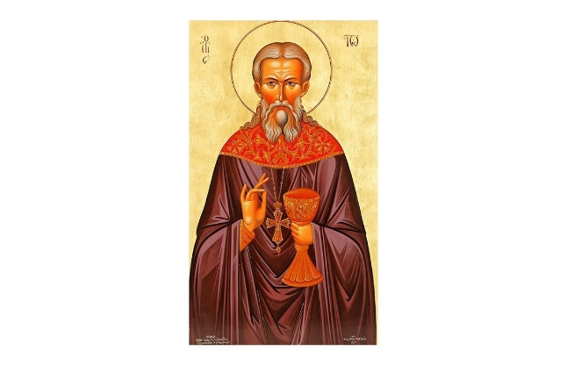

Yesterday the Orthodox Church commemorated St John of Kronstadt, a late nineteenth-, early twentieth-century priest, who served at the Russian naval base near St Petersburg. During his ministry he was accredited with many healing miracles as a result of his constant prayers for sick individuals. His personal testimony, *My Life in Christ,* is rightly considered a classic of Russian ascetical theology.

John, however had a blind spot, something which was shared by many in Czarist Russia. This, tragically and topically, was antisemitism. There was a pogrom in a place called Kishinev in 1903, in which around fifty Jews were killed, many more were injured, and fifteen hundred homes damaged. Although at first he condemned the outrage, he subsequently recanted and blamed the whole incident on the Jews themselves, a classic case of victim-blaming.

How could a man, so obviously used by God through his praying and writing, and so obviously divinely gifted, succumb to such a hateful view of his fellow citizens? The answer comes from the testimony of the Saints themselves. John, like all other Saints, knows that he is not the finished product, but is on a journey towards holiness. Indeed, in *My Life in Christ,* he confesses that the ‘darkness of spiritual anger’ often surrounds his heart. Nevertheless, it appears, he never acknowledges his antisemitism.

That a man so holy could be so blind to his own sin is disconcerting, but at the same time it is a warning to us all. It forces me to ask myself the question, ‘In my life in Christ, where are MY blind spots which prevent me from becoming the person who Christ wants me to be?’ In the Orthodox Church, as in Catholic and some Anglican churches, we are encouraged to make a regular confession of our sins before a priest. Preparation for this sacrament involves a very disciplined and detailed scrutiny of our life since our previous confession, and this is designed to identify those areas in our lives in which we fall short of Christ’s call to holiness.

Even so, there is always the temptation to focus on the trivial rather than on the more damaging aspects of our conduct or attitudes, to pass off or exclude things which should be included, to bury somewhere in our unconscious things which deep down we do not want to face up to. There is within us a constant temptation to allow blind spots to remain blind spots, rather than exposing them to Christ. Only through the light of His grace, shining directly within our hearts, or shining indirectly through the advice of those who love us, can they be exposed.

**We enter the silence** with words of St Hesychios the Priest (8th century):

*The guarding of the mind may be appropriately called ‘light-producing’, ‘lightning producing’, ‘light-giving’ and ‘fire-bearing’, for truly it surpasses endless virtues.*

**We leave the silence** with the words of Christ in St Matthew 7 verse 3:

*And why do you look at the speck in your brother’s eye, but do not consider the plank in your own eye? Hypocrite! First remove the plank from your own eye, and then you will see clearly to remove the speck from your brother’s eye.*