Wellsprings of Stillness
At first this may seem a bit of a contradiction, to link the idea of moving water (as in a spring) with the concept of stillness! But I would like to share some ways in which I have been much helped by this surprising but nevertheless powerful imagery.
Some time ago a dear friend gave me a beautiful stone on which she had inscribed the words: ‘Fountain of Stillness’. Next to that stone I have placed an icon portraying the moment when Jesus talks with the woman of Samaria at the well, and says to her:
‘Everyone who drinks of this water will be thirsty again, but those who drink of the water that I will give them will never be thirsty. The water that I will give will become in them a spring of water welling up to eternal life.’ (John 4:13-14)
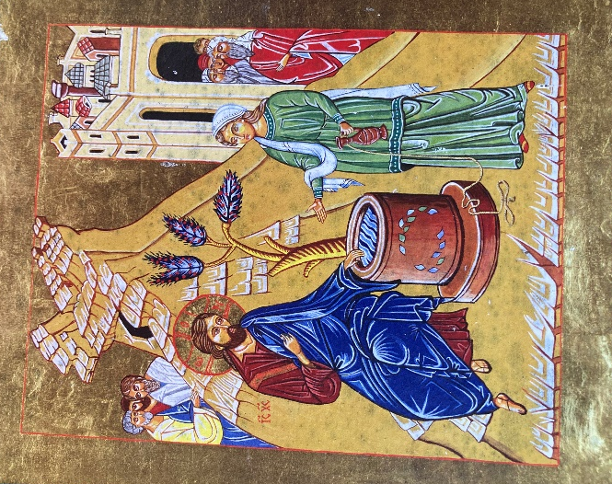 (Icon by the late John Coleman, for the Association for Promoting Retreats)
Also, on one of the first retreats I ever attended, the leader spoke about how we can dip into the underlying stream of God’s silent presence, flowing beneath all our surface activities, at any moment. All these years later I am still learning, and re-learning, how to engage with that!
Finally, there’s the idea of the ‘pool of silence’ in which we can immerse ourselves when we pray. This is not a brackish or stagnant pool, but is constantly replenished by hidden, fresh-flowing streams.
In all of these water-related images, the silence and stillness that they convey are not our achievement, let alone our possession, but are God’s gift to us.
So, to lead us into silence, here are some lines I once wrote in another context:
As we plunge into the clear, tranquil pool of prayer,
the Holy Spirit permeates us
with abundant grace,
refreshing us with the quiet surprise of deep peace.

At the end of the silence
The Lord is my shepherd, I shall lack nothing.
He feeds me in green pastures; he leads me beside still waters.
He restores my soul. Psalm 23 vv. 1-3a

